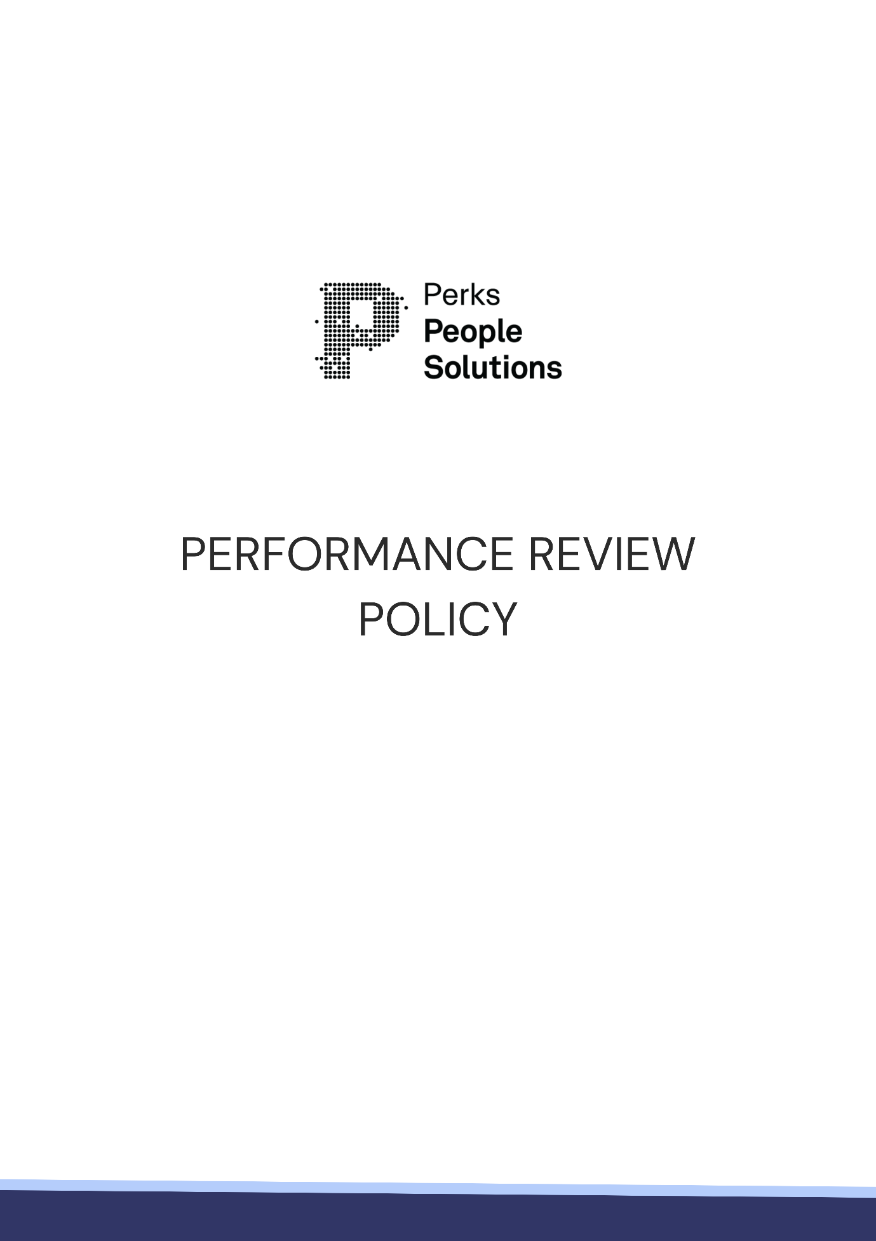

Performance Review Policy
SCOPE
This policy applies to all employees of [INSERT COMPANY NAME]. Unless specified otherwise, employees referred to in this policy mean permanent, fixed term, full-time or part-time and casual employees of [INSERT COMPANY NAME]. This policy must be read in conjunction the Fair Work Act 2009 (Cth), the National Employment Standards and any relevant industrial instrument, including an award.
AIM
Performance reviews serve as a means by which both management and employees can actively participate in the evaluation and development of employee productivity and performance through the setting of key target goals and objectives. By facilitating open communication between employer and employee, performance reviews allow for the provision of feedback, guidance and support as to the employee’s role within [INSERT COMPANY NAME].
This is important in ensuring that work performance and overall efficiency is held to a high standard, and that employees are informed of areas where improvement is necessary. Furthermore, such reviews also provide management with an opportunity to recognise and reward employee output.
The purpose of the performance review is to:
- facilitate open interaction between Management and the employee with a view to identifying strengths and development areas, as well as opportunities for education, training and improvement;
- provide an opportunity for [INSERT COMPANY NAME] to clarify and articulate the expectations, goals, standards and objectives for the employee;
- where necessary, identify areas of poor or under performance where the standard of work expected by [INSERT COMPANY NAME] is not being met, so that performance deficiencies can be duly rectified;
- measure and evaluate an employee’s work performance to assist in the setting of future expectations, goals, standards and objectives;
- receive feedback from the employee regarding ways to improve overall efficiency and productivity within the company, as well as to identify any concerns from the employee; and
- provide an objective basis on which to base decisions about training, development and promotion, and to assist in any decisions regarding succession planning.
POLICY
It is expected that all employees have regular discussions with their Manager throughout the year in relation to their performance, outside of the formalised, annual performance review process.
During the formal performance review process, each employee will meet with their Manager to do the following:
- reflect on the employee’s performance and achievements throughout the review period;
- assess the employee’s performance, relative to key performance criteria detailed in the employee’s job specification and goals agreed at the start of the review period;
- celebrate achievements and successes, and identify areas for growth and development;
- identify and discuss any obstacles to progress or goal achievement;
- set key performance criteria for next review period;
- identify any relevant training or education required.
It is intended that the performance review process is a two-way discussion between an employee and their Manager, so that forward goals are mutually agreed, performance expectations are established, and plans can be made (if any) in respect of any training or development opportunities.
Performance Review Procedure
The Manager will conduct an annual performance review with each employee they supervise. If deemed necessary by the Manager, performance reviews may be undertaken more frequently. Again, it is expected that the Manager and their employee will engage informally throughout the year to discuss performance-related matters.
Employee Self-Assessment
Before meeting with their Manager for their performance review meeting, an employee may be required to complete a self-assessment for evaluation by their Manager. This enables the employee to reflect on their performance and plans for the upcoming review period, and assists the Manager to conduct the review.
Performance Review Documents
Before meeting with their employee, a Manager is required to complete the necessary performance review documents. Again, the purpose of doing so is to assist the Manager to prepare for, and conduct, the review.
If the Manager has any performance concerns, these may be detailed for the employee, in writing, ahead of the meeting.
The Performance Review Meeting
At the meeting, the Manager and the employee will review and discuss the pre-meeting documentation, as well as undertake the discussion points noted above.
Closing the Review
The Manager is responsible for maintaining the performance review documents, with particular emphasis on ensuring that they accurately reflect what was discussed. All records relating to the performance review process, whether it is part of the annual review process or a discussion that occurs during the course of the year, are confidential and will be kept on the employee’s personnel file.
When the performance review is complete, both parties should sign the performance review documents. If the employee refuses to sign the documents, this should be noted.
If the employee disagrees with the outcome of the performance review process and/or evaluation, they may submit a written response, which will be considered, and placed in their personnel record.



Exposure to Trauma Policy
SCOPE
This policy applies to all [INSERT COMPANY NAME] employees, contractors, and volunteers who may be exposed to trauma or secondary trauma as part of their work duties.

This policy is guided by relevant legislation including:
- List relevant state or territory work health and safety legislation

AIM
This policy outlines our commitment to proactively identifying, managing, and minimising psychosocial risks associated with exposure to trauma and secondary trauma. Our aim is to promote a supportive, trauma-informed culture where early identification, timely response, and recovery support are embedded in our way of working.

POLICY
At [INSERT COMPANY NAME], we are committed to creating a psychologically safe workplace for all employees. We recognise that certain roles may involve exposure to traumatic events or materials, which can lead to primary or secondary trauma.

We have a duty of care under the [INSERT STATE OR TERRITORY WORK HEALTH AND SAFETY LEGISLATION] to manage psychological hazards, and we take this responsibility seriously. We are committed to identifying risks early, providing appropriate supports, and promoting a culture where psychological wellbeing is valued and protected.

Examples of trauma may include (but are not limited to):
Primary Trauma (Direct Exposure)
- Witnessing or being involved in a serious injury or fatality on-site
- Being first on the scene of a critical incident (e.g. fall from height, machinery entrapment)
- Experiencing a near-miss that could have resulted in serious harm or death
- Being physically assaulted by a member of the public or another worker
- Exposure to hazardous events, such as fire, explosion, or structural collapse
- Working in or near disaster zones or emergency response sites
- Experiencing violence or threats on remote or isolated job sites

Secondary Trauma (Indirect Exposure)
- Hearing detailed accounts of traumatic incidents from injured coworkers
- Providing emotional support to colleagues after an incident
- Reviewing CCTV or incident footage involving serious injury or death
- Reading or preparing incident reports involving traumatic events
- Participating in post-incident investigations, coronial inquiries, or legal proceedings
- Repeated exposure to discussions about fatal or life-altering incidents (e.g. toolbox talks, safety stand-downs)
- Cumulative stress from working in high-risk environments over extended periods

Cumulative and Ongoing Exposure
- Regularly witnessing unsafe behaviours or near-misses
- Managing or supervising injured or traumatised workers
- Long-term exposure to distressing or emotionally charged complaints (e.g. sexual harassment, workplace bullying).

Responsibilities
Employers/Managers/Supervisors are responsible for:
- Ensuring this policy is communicated, understood, and enforced
- Identifying and assessing risks related to trauma exposure
- Implementing control measures to reduce harm (e.g. workload management, supervision, training)
- Providing access to psychological support
- Promoting a culture of safety, openness, and support
- Training leaders to identify and respond to signs of trauma or distress
- Monitoring signs of distress in teams and take prompt action when concerns arise

Employees are responsible for:
- Engaging in self-care and using available support
- Reporting any workplace-related incident, near miss or concern to a Manager or [INSERT TITLE OF WH&S REPRESENTATIVE]
- Reporting incidents or concerns about trauma exposure in the workplace to a Manager or [INSERT TITLE OF WH&S REPRESENTATIVE]
- Participating in training and debriefing as required
- Being respectful and supportive of colleagues

PROCEDURE
Recognising the Signs of Trauma
Supervisors should be alert to signs such as:
- Withdrawal or uncharacteristic mood swings
- Increased absenteeism or presenteeism
- Irritability or heightened reactions to stress
- Trouble concentrating or making decisions
- Physical symptoms like fatigue or headaches
- Decreased tolerance of risk or careless safety behaviour

Responding to Trauma Exposure
Employees who are affected by exposure to trauma are encouraged to report their concerns to their supervisor or manager. Reports will be handled confidentially and sensitively. A tailored response plan may be developed, including time off, modified duties, or referral to mental health support.

Critical incidents (e.g. exposure to violence, death, distressing content) will be followed by an organisational debrief and review of supports offered.

Support and Assistance
Employees affected by trauma in the workplace will be offered:
- Access to counselling or mental health support
- Optional trauma-informed debriefing following critical incidents
- Flexible work arrangements when needed (e.g. after a traumatic incident), subject to operational need
- Ongoing support through [INSERT TITLE OF WH&S REPRESENTATIVE] or Human Resources Consultant

All disclosures will be treated sensitively, without stigma or prejudice.

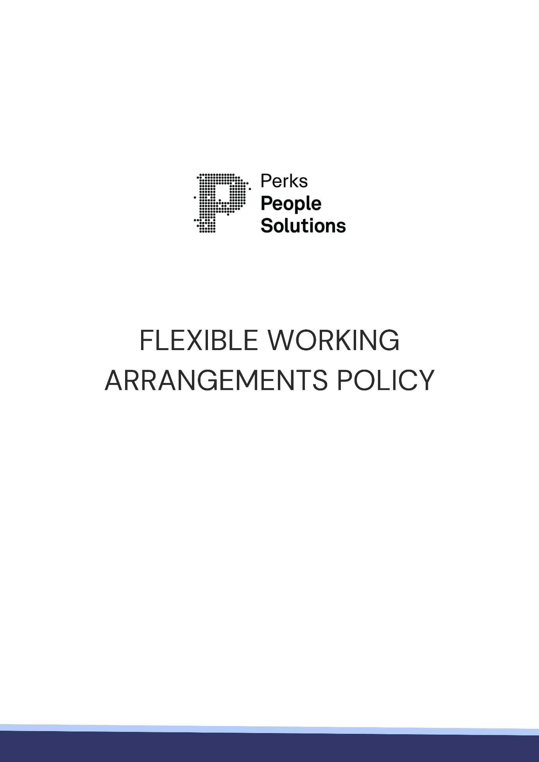

Flexible Working Arrangements Policy
SCOPE
This policy applies to all permanent and fixed-term employees of [INSERT COMPANY NAME], including full-time or part-time employees. This policy also has limited application to casual employees, as detailed below. The policy must be read in conjunction with the Fair Work Act 2009 (Cth) (FW Act), the National Employment Standards (NES) and any relevant industrial instrument, including an award.
AIM
The purpose of this policy is to ensure that all [INSERT COMPANY NAME] employees are aware of their entitlements in relation to flexible working arrangements and the business’ obligation to consider such requests.
A flexible working arrangement is a modification to an employee’s usual work arrangement. Examples are changes in hours of work, changes in patterns of work and changes in work locations.
An employee may request a flexible working arrangement for a fixed or an indefinite period of time, but it should be clear and subject to regular review.
POLICY
[INSERT COMPANY NAME] recognises that there are times when employees may need to request a change in their work arrangements in order to meet their parental or carer responsibilities, when undertaking study, to prepare for transition into retirement, to find a work/life balance to accommodate personal pursuits or hobbies or for some other reason. [INSERT COMPANY NAME] employees may request flexible work arrangements and are required to put these requests in writing to their Manager.
To comply with the FW Act, [INSERT COMPANY NAME] will consider this request and all relevant facts and circumstances in deciding whether or not to agree to the request. Such a request will not be refused unless it is reasonable to do so.
Circumstances that may be relevant to determining whether a request is reasonable include:
- the nature of the employee's work and parental or carer responsibilities;
- the nature and cost of the arrangements required for an employee to fulfil their family or carer responsibilities;
- the financial circumstances of the employer;
- the effect of the arrangement on the workplace, including the financial impact on the business;
- the consequences for the employer of having the arrangement;
- the consequences for the employee of not having the flexible working arrangement.
Other factors that might be relevant in a particular case include:
- when the arrangement is to commence;
- how long the arrangement will last;
- information that has been provided by the employee about their situation;
- the accrued entitlements of the employee, such as personal, carer's or annual leave;
- whether any legal or other constraints affect the feasibility of the employer accommodating the responsibilities, such as work, health and safety laws or award penalty rates.
In addition, under the NES, employees who have at least 12 months continuous service, who, among other scenarios as detailed in the FW Act, provide care to a child under school age, or care for a child under 18 with a disability, have the right to request flexible working arrangements.
This right applies to all employees including permanent full-time and part-time employees, as well as casual employees (if they have worked for the same employer regularly and systematically for at least 12 months and there is reasonable expectation of this continuing), regardless of role or job function.
[INSERT COMPANY NAME] will discuss the request with the employee with the aim of genuinely trying to reach agreement with the employee. This may include proposing an arrangement that differs from the employee’s request, but that aligns with the business’s operational needs.
[INSERT COMPANY NAME] will provide a written response granting or refusing the request within 21 days of the request being made, and will only refuse such requests on reasonable business grounds. [INSERT COMPANY NAME] may offer an alternative flexible working arrangement, as discussed with the employee. If the request is refused, these reasons will be detailed in the written refusal.
Options for Flexible Work Practices
Flexible work options which may be considered by [INSERT COMPANY NAME] include:
- permanent, part-time work;
- gradual return to work (for employees returning from parental leave), e.g. the employee returns part-time and then builds up to full-time work, flexible start and finish times for staff to accommodate childcare and school pick-up requirements;
- work from home;
- compressed hours – where the employee works additional daily hours to provide for a shorter working week or fortnight.
This is not an exhaustive list, and other options may be agreed.
Employees utilising flexible work practices will be treated no less favourably than any other employee.

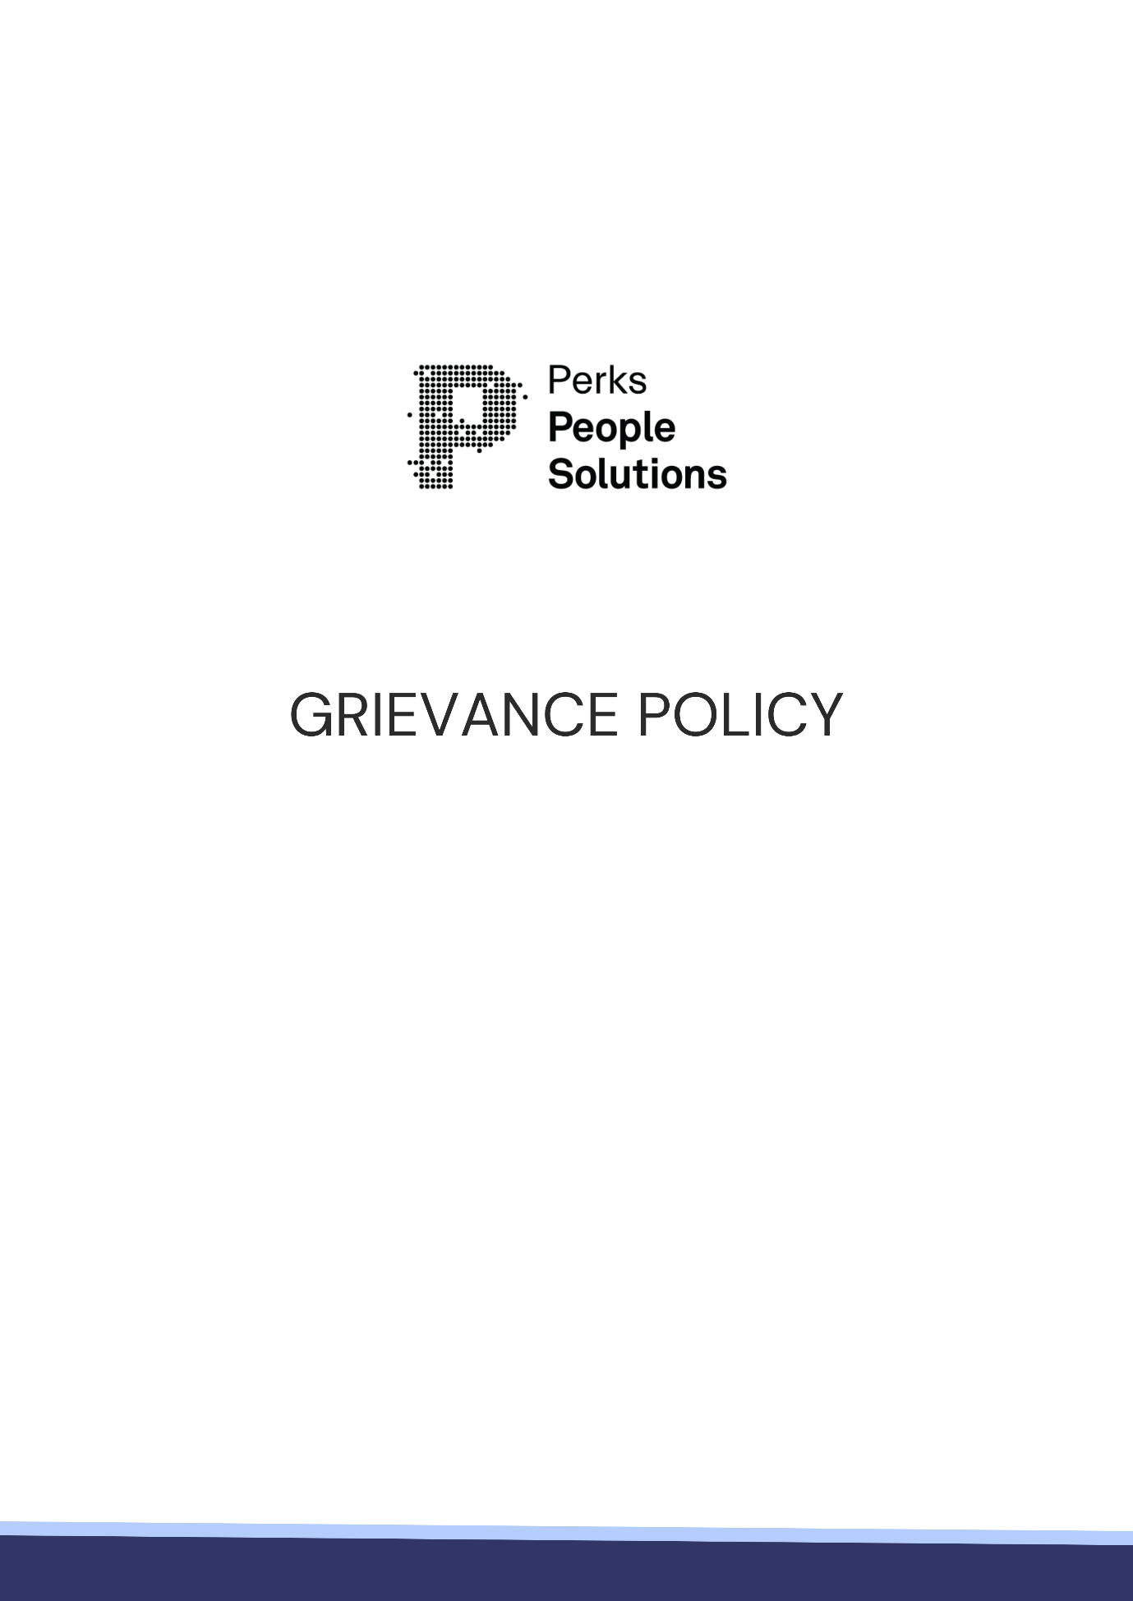

Grievance Policy
SCOPE
This policy sets out the processes for handling of work-related grievances at [INSERT COMPANY NAME] including, but not limited to, a response to harassment, discrimination, bullying, victimisation or vilification in the workplace. In certain instances where unlawful behaviour may be involved or where administrative mechanisms for appealing decisions may exist, then other processes are followed as described in the next section.
To the extent relevant, this policy will be read in conjunction the Fair Work Act 2009 (Cth), the National Employment Standards and any relevant industrial instrument, including an award.
AIM
The aim of this policy is to assist employees and managers when dealing with work-related grievances and conflict matters. This policy provides guidelines to assist toward:
- ensuring procedural fairness;
- facilitating a consistent handling of grievances across the business;
- meeting best practice standards of grievance handling; and
- the achievement of timely resolution of grievances.
[INSERT COMPANY NAME] is committed to providing a productive and harmonious work environment. This policy aims to maintain effective working relationships by ensuring that grievances are handled quickly, with minimum distress and maximum protection to all parties, thereby preventing the escalation of minor problems or grievances.
POLICY
This policy defines work-related grievances and describes how they are to be handled by [INSERT COMPANY NAME]. It advises on the responsibilities of Managers and staff, how to raise a grievance, the expected outcomes of the process, and documentation.
This policy establishes the principles by which work-related grievances are handled and a framework for the management of grievances according to equity principles and legislative requirements.
DEFINITIONS
A work-related grievance is any type of problem, concern or complaint where an employee believes that they have received unreasonable treatment from [INSERT COMPANY NAME], another employee of [INSERT COMPANY NAME], or a contractor or subcontractor engaged by [INSERT COMPANY NAME] and wishes to bring the grievance to the attention of [INSERT COMPANY NAME] for action or response.
There are two types of work-related grievances, those involving:
- behaviour which does not contravene any laws or legislation, but which is still inappropriate, such as interpersonal conflicts, personal issues or work practices; and
- potentially unlawful behaviour which, depending upon its nature, may be covered by legislation that will determine how these grievances are handled.
This distinction determines how grievances will be dealt with, and the extent and type of documentation required.
Policy Principles
Grievance resolution is an integral part of management responsibility at [INSERT COMPANY NAME]. Managers have the responsibility to take all reasonable steps to identify and attempt to prevent, and resolve, problems in the workplace.
Employees raising a grievance, as well as the employee or person who is the subject of the grievance, have the right to choose to be accompanied by a support person of their choice during all discussions related to the grievance. Confidentiality is respected at all times within the constraints of the need to fully investigate the grievance, which extends to the employee’s/person’s support person.
Grievances will be dealt with promptly and take into account the interests of all concerned. The relevant Manager, or suitable representative from [INSERT COMPANY NAME], will respond to the employee raising the grievance (either by discussing the matter with the employee or arranging a meeting) within five working days of being notified of the grievance.
Whenever possible, the wishes of the employee raising the grievance in relation to the resolution process will be taken into account. However, this may not be possible in some circumstances.
How to raise a grievance and how it will be dealt with
In the first instance, the grievance should be raised with the relevant Manager. Grievances may be raised verbally in the first instance, although they may have to be formalised in writing later, depending on the circumstances.
Employees should be aware that, if the grievance is of a serious nature or involves allegedly unlawful behaviour, a formal investigation is required, which must be documented. This may include the notifying employee (and any other relevant persons, including the alleged perpetrator) participating in an interview, which may be recorded and transcribed.
Although an employee may withdraw their grievance, it is ultimately for the [INSERT COMPANY NAME] to determine the most appropriate course of action. In some circumstances, if a grievance relates to alleged unlawful behaviour, unsafe behaviour, criminal behaviour or conduct that may give rise to employer liability, [INSERT COMPANY NAME] may determine that the grievance should be fully investigated.
Any investigation process undertaken will be conducted in a timely and procedurally fair manner. Any employee/person who is the subject of a grievance will be given sufficient information about the grievance, time to consider that information, and a reasonable opportunity to respond.
Outcomes of the Grievance Resolution Process
Where a grievance is substantiated, [INSERT COMPANY NAME] will take all necessary steps to address the matter. This may take various forms, such as workplace intervention, training and education, mediation, or disciplinary action.
Where possible, an employee who lodges a grievance will receive written notice regarding the outcome of the grievance process.
In instances where the facts surrounding a grievance cannot be substantiated, it is possible that no further action will be taken, however, it does depend on the nature of the grievance and the information gathered during the investigation phase.
External Process
If an employee, who raises a grievance, is dissatisfied with the outcome, the employee may choose to seek the assistance of an external party. However, [INSERT COMPANY NAME] encourages an employee to exhaust all internal avenues (including approaching the relevant Manager or business representative) to ascertain whether there are any other internal avenues that are available to address their concerns.
If all internal avenues have been exhausted, or it is otherwise the employee’s preference, the external options include:
- Fair Work Commission (www.fwc.gov.au)
- Australian Human Rights Commission (www.humanrights.gov.au)
- State or Territory anti-discrimination agency
- State or Territory work health and safety regulator
Documentation
Documentation relating to the grievance will be placed on the employee’s personal file. While a matter is the subject to investigation, the relevant documentation may be held elsewhere, either in hard of soft copy. Confidentiality of all documentation will be maintained, and will only be accessible by the necessary personnel.
Responsibilities
All employees have a responsibility to contribute to the achievement of a productive, safe and equitable work environment at [INSERT COMPANY NAME].
Management is responsible for:
- responding appropriately to grievances and managing the process according to [INSERT COMPANY NAME] policies, principles and procedures;
- responding appropriately;
- modelling the behaviour expected of all employees, particularly as it relates to grievance handling.
Employees raising a grievance are responsible for:
- participating in the grievance resolution process in good faith;
- co-operating fully in the investigative process;
- not making vexatious complaints or raising grievances with malicious intent;
- not reporting a grievance to several different individuals at the same time
- maintaining confidentiality and avoid commenting on the grievance process whilst it is being undertaken.

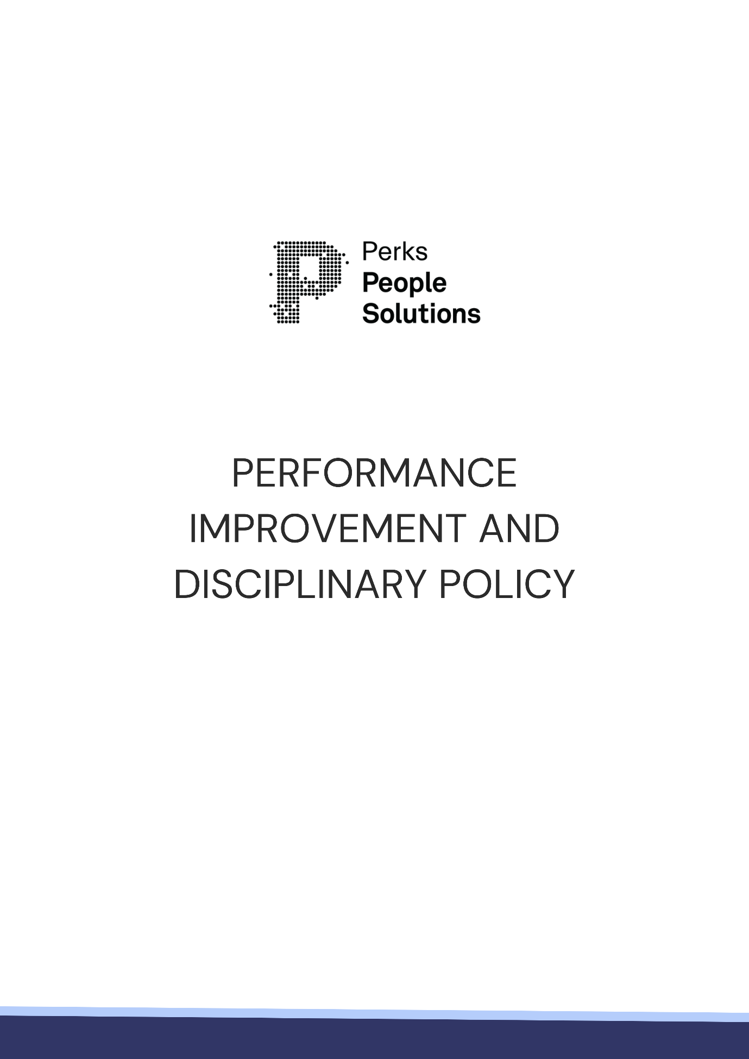

Performance Improvement and Disciplinary Policy
SCOPE
This policy applies to employees of [INSERT COMPANY NAME]. Unless specified otherwise, employees referred to in this policy mean permanent, fixed term, full-time, part-time or causal employees of [INSERT COMPANY NAME]. This policy must be read in conjunction the Fair Work Act 2009 (Cth) (FW Act), the National Employment Standards (NES) and any relevant industrial instrument, including an award.
AIM
The aim of this policy is to set out the procedures that will be followed in the event that a performance or disciplinary issue arises, so as to ensure that all individuals are treated in a fair and equal manner.
In short, this policy aims to ensure that:
- all parties are afforded an opportunity to present their side of the story, and to respond to any allegations made or concerns raised;
- all parties understand where they stand at any given time;
- all parties are actively involved in determining what course of action needs to be taken to rectify the issue; and
- ‘spur of the moment’ decisions are avoided.
POLICY
[INSERT COMPANY NAME] is committed to ensuring that, when performance or behavioural matters arise, the employee concerned is treated fairly and equitably, and in accordance with the FW Act and the NES, ensuring optimum standards of natural justice and procedural fairness.
Management will address any such issues in accordance with this policy.
PROCEDURE
The procedure that will be taken will be determined by the nature and seriousness of the issue in question. Different approaches will be taken in response to Poor Performance, Inappropriate Workplace Behaviour and/or Misconduct and Serious and Wilful Misconduct. The contrasting procedures are outlined below.
- Poor Performance
The following process will apply in circumstances where an employee’s performance or behaviour is not meeting [INSERT COMPANY NAME] expectations.
Step One
Counselling/Informal Warning
The Manager should provide the employee with verbal feedback about any aspect of their performance, or behaviour, that requires improvement as needed. This feedback should identify the issue, explain/reiterate the Manager’s expectation and, where appropriate, identify a timeframe for improvement. The employee is encouraged to ask questions or seek clarification from the Manager.
The Manager will make file note of any discussion.
Step Two
Formal Warning
If the performance or behaviour of the employee does not improve within a reasonable timeframe, they will be invited to attend a meeting with their Manager. The purpose of the meeting is to allow the Manager to identify the area(s) of underperformance or inappropriate behaviour, reiterate the Manager’s expectation in terms of the required performance and/or behaviour, and to provide a timeframe for improvement. The employee will also be notified that, if sufficient improvement is not achieved with the specified timeframe, it may result in termination of employment. In some circumstances, the Manager may require the employee to participate in a Performance Improvement Plan (PIP).
The employee will be given the opportunity to respond to the information presented and ask any questions or seek clarification.
If a PIP is commenced, it will detail the performance and behavioural standard expected, and the timeframe for improvement. What constitutes a reasonable timeframe for improvement will vary and will depend upon the individual circumstances of each case. The PIP will also confirm the frequency and timing of any meeting to periodically assess the employee’s improvements.
Step Three
Subsequent and Final Warning
In the event that the employee’s performance and/or behaviour does not improve sufficiently, whether that is in accordance with a PIP or otherwise, further action will be taken. This may include further discussions with the employee’s Manager, an extension of the PIP, or the commencement of a disciplinary process. The outcome of any disciplinary process may result in the imposition of a subsequent or final warning.
Where a warning is issued, the employee will be advised that, if their performance and/or behaviour does not improve to the required standard within the agreed time frame, their employment may be terminated.
Step Four
Termination of Employment
If, despite all efforts to assist and support the employee improve to the required standard in terms of performance or behaviour, their employment will be terminated.
- Inappropriate Workplace Behaviour and/or Misconduct
On occasion, employees can behave in a manner that is inappropriate in the workplace or amounts to misconduct. In such circumstances, a different approach is warranted.
If an employee is believed to have engaged in misconduct or inappropriate workplace conduct, [INSERT COMPANY NAME] will take steps to investigate the matter. This will include speaking to the relevant persons, including the employee alleged to have behaved inappropriately.
Once all of the information is gathered, [INSERT COMPANY NAME] will make a decision as to the appropriate disciplinary action, if any. Depending on the severity of the behaviour substantiated, disciplinary action may include the imposition of a warning, the direction to participate in training or development or the termination of the employee’s employment.
- Serious and Wilful Misconduct
In the event that an employee engages in serious or wilful misconduct, instant dismissal may be justified. However, before any decision is made in respect of the employee’s employment, [INSERT COMPANY NAME] will take steps to investigate the matter, and follow a procedurally fair process.
Other Possible Management Action
[INSERT COMPANY NAME] reserves the right to suspend the employee on full pay pending investigation where we have reasonable grounds to believe that an employee’s continued employment might be prejudicial to our business or other employees.
[INSERT COMPANY NAME] reserves the right to exclude the employee from the premises during their period of notice and shall be under no obligation to provide any work for the employee or to assign them any duties during that time.

